CARMELTAZITE
ZrAl₂Ti₄O₁₁
Optical & Dielectric Characterisation of Natural Carmeltazite
and Proposal of an Integrated Photonic Architecture
with Radial Concentric Topology
――――――――――――――――――――
Domain: Integrated Photonics / Materials Science
Version 3.0 — March 2026 — Research Blueprint
Status: Pre-experimental. For peer review and laboratory partnership.
Epistemic Status Key
A1 / A2 / A3 | H1 | H2 | H3 | C1 / C2
Axiom  (measured) | Hypothesis  (plausible) | Hypothesis  (extrapolated) | Hypothesis  (synthesis) | Conjecture  (speculative)

Abstract
This document constitutes the research blueprint for an experimental programme in two phases. Phase 1: optical and dielectric characterisation of natural carmeltazite (ZrAl₂Ti₄O₁₁) specimens from the Hatrurim Complex, Mount Carmel, Israel. Phase 2: formalisation and topological analysis of a four-layer integrated photonic architecture organised along a radial concentric topology, structurally isomorphic to the Gothic rose window.

The central claim is precisely bounded: carmeltazite constitutes a mineralogically coherent model — not a demonstrated substrate — for an integrated terabit-class photonic interconnect. Its natural co-crystallisation of ZrO₂, Al₂O₃, and TiO₂ in a single orthorhombic lattice provides a structural template for what thin-film engineering attempts to assemble in successive deposition layers. All photonic properties attributed to carmeltazite in this document are extrapolated (H2) and require direct measurement before any claim can be promoted to axiom.

The rose window isomorphism is formalised at three rigorous levels — topological (graph theory), variational (flux optimisation), and transmorphic (structural morphology) — with explicit identification of where the analogy holds and where it breaks. This formal treatment transforms a rhetorical parallel into a falsifiable structural proposition.

Keywords: carmeltazite • ZrAl₂Ti₄O₁₁ • integrated photonics • optical waveguide • high-k dielectric • radial concentric topology • Gothic rose window • graph homomorphism • transmorphism • optical characterisation • falsifiable hypotheses

I. Scientific Context and Problem Statement

1.1 The Material Integration Problem in Photonics
Contemporary integrated photonic circuits operating in the telecom C and L bands (1530–1625 nm) impose a set of simultaneous material constraints that no single commercially deployed material satisfies in full:

Property | Required Value | Rationale | Status in CML*
Refractive index n @ 1550 nm | n > 1.9 | Modal confinement in 500 nm guide | H2
Optical absorption loss | < 1 dB/cm @ 1550 nm | Viable propagation length | H2
Dielectric constant εr | εr > 15 | Active phase shift < 3 V | H2
Thermal stability | > 450°C | CMOS back-end compatibility | A1
Surface roughness | < 0.3 nm RMS | DUV/EUV lithography | H2
Crystalline phase stability | Orthorhombic ZrAl₂Ti₄O₁₁ | Phase-dependent optical properties | A1

* CML = Carmeltazite. A1: established by mineralogical record. H2: extrapolated from constituent oxides, unmeasured.

1.2 Carmeltazite as a Natural Template
Carmeltazite was identified as a new mineral species by Murashko et al. in 2017, from pyrometamorphic xenoliths of the Hatrurim Complex, Negev Desert, Israel. Its ideal chemical formula is ZrAl₂Ti₄O₁₁, with an orthorhombic crystal system and a defective spinel-related structure in which Zr⁴⁺, Al³⁺, and Ti⁴⁺ occupy distinct crystallographic sites (tetrahedral and octahedral). [A1]

The mineralogical significance is the following: the three constituent oxides of carmeltazite — ZrO₂, Al₂O₃, TiO₂ — are precisely the materials that advanced thin-film photonic engineering deploys in successive ALD layers for respectively: high-k gate dielectrics (ZrO₂:Al₂O₃), low-loss optical waveguides (TiO₂ anatase), and active electrostatic modulators (Al₂O₃ host matrix). Carmeltazite achieves their co-crystallisation in a single lattice formed under extreme thermodynamic conditions (T > 1200°C, rapid quench). [A1] Whether this co-crystallisation produces emergent optical properties distinct from a weighted average of the constituent oxides is the central unfalsified hypothesis of this programme. [H1]

1.3 Scope of This Blueprint
This document is bounded to two deliverables:
- Experimental characterisation protocol for natural carmeltazite specimens: five priority measurements, defined techniques, success thresholds, and falsification criteria.
- Architectural formalisation: a four-layer radial concentric photonic topology, formally derived and structurally justified via graph-theoretic isomorphism with the Gothic rose window.
Explicitly out of scope: ALD synthesis of carmeltazite (H3), CMOS process integration, device-level modelling, and system-level terabit demonstrations. These constitute a subsequent programme contingent on Phase 1 results.

II. Carmeltazite — Known and Hypothetical Properties

2.1 Established Properties (Axiom Level)
Property | Value | Source | Status | Epistemic
Chemical formula | ZrAl₂Ti₄O₁₁ | Murashko et al. 2017 | Measured | A1
Crystal system | Orthorhombic | XRD (Murashko 2017) | Measured | A1
Space group | Cmce (No. 64) | XRD (Murashko 2017) | Measured | A1
Formation temperature | > 1200°C | Pyrometamorphic context | Contextual | A1
Occurrence | Hatrurim Complex, Negev, Israel | Mineralogical record | Confirmed | A1
Lattice parameters | a=9.74, b=10.28, c=5.06 Å | Murashko et al. 2017 | Measured | A1

2.2 Hypothetical Properties (Extrapolated — Unmeasured)
The following properties are estimated by linear mixing rules applied to published data for the constituent oxides (ZrO₂, Al₂O₃, TiO₂) weighted by stoichiometric fraction. This extrapolation methodology is standard in materials screening but carries a known limitation: it ignores crystal-field effects, inter-site charge transfer, and possible emergent electronic structure at the Zr–Ti interface. The uncertainty intervals reflect this limitation. [H2]

Property | Estimated Value | Uncertainty | Measurement Required | Status
Refractive index n @ 1310 nm | n ≈ 2.15 | ±0.20 | Spectroscopic ellipsometry | H2
Refractive index n @ 1550 nm | n ≈ 2.0–2.3 | ±0.15 | Spectroscopic ellipsometry | H2
Refractive index n @ 1625 nm | n ≈ 1.95–2.25 | ±0.15 | Spectroscopic ellipsometry | H2
Absorption loss @ 1550 nm | < 5 dB/cm (estimated) | Unknown | Spectrophotometry UV-Vis-NIR | H2
Optical bandgap Eg | ≈3.0–3.5 eV (TiO₂-dominated) | ±0.3 eV | UV-Vis spectroscopy | H2
Dielectric constant εr (1 MHz) | εr ≈18–25 | ±4 | Capacitance-voltage (C-V) | H2
Birefringence | Biaxial (orthorhombic)  Δn unknown | Not characterised | Polarimetry | H1
Nonlinear index n₂ | Unknown | Not characterised | Z-scan @ 1550 nm | H2

2.3 Comparative Position Among Candidate Substrates
Figure 1 positions carmeltazite within the landscape of photonic substrate candidates on the primary screening criterion: refractive index at 1550 nm. The modal confinement threshold (n = 1.9) is indicated; materials below this threshold cannot support single-mode propagation in sub-micron waveguide cross-sections.

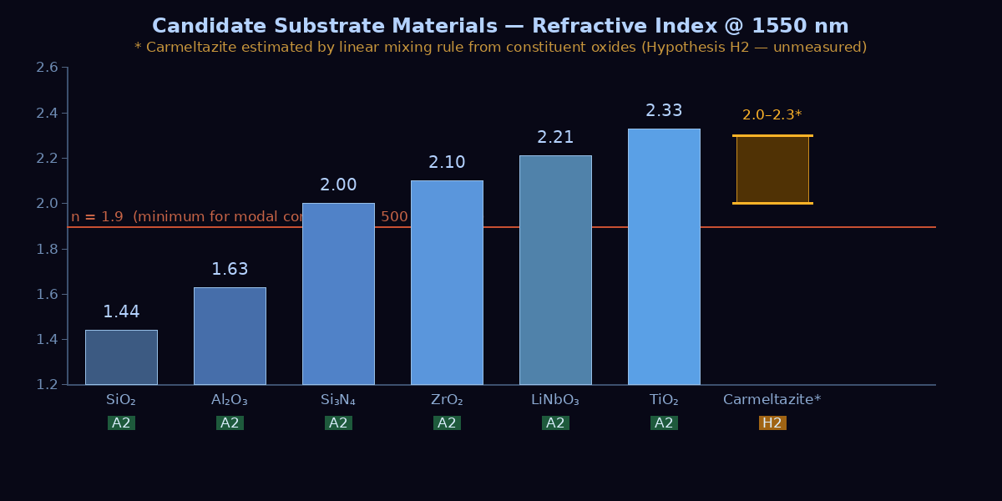
Figure 1. Refractive index at 1550 nm for candidate photonic substrates. The orange bar (carmeltazite) represents the extrapolated interval [2.0–2.3] from constituent oxide data (H2). Green = measured (A2). The dashed red line indicates the minimum index for modal confinement in a 500 nm × 220 nm waveguide cross-section.

III. Priority Characterisation Protocol
The following protocol defines the minimal experimental programme required to promote carmeltazite from hypothesis to axiom. The five measurements are ordered by scientific impact relative to estimated cost. All photonic architecture claims in Section IV are contingent on the results of this protocol. A negative result in Measurement 1 or 2 would invalidate the terabit substrate hypothesis and redirect the research toward alternative high-index materials.

3.1 Specimen Acquisition Strategy
Before any measurement, natural carmeltazite specimens must be sourced. Three documented routes:
- Murashko et al. (2017) affiliated collections: Direct contact with the Fersman Mineralogical Museum (Moscow) or the Geological Survey of Israel (GSI, Jerusalem), both of which hold authenticated Hatrurim Complex xenolith specimens.
- Natural History Museum (London): Hatrurim Complex mineral collection. Sample loan for research purposes is standard practice under formal institutional agreement.
- RRUFF Project (University of Arizona): Verify whether carmeltazite is indexed with Raman and XRD reference spectra. If so, request specimen access or obtain reference data for preliminary identification of any candidate specimen.
Minimum specimen requirement: Two polished sections, 5×5 mm, thickness 0.5–1 mm, oriented parallel and perpendicular to the crystallographic c-axis. One for optical measurements (non-destructive), one for electrical measurements (may require electrode deposition).

3.2 Five Priority Measurements

Measurement 1: Spectroscopic Ellipsometry (n, k @ 1310–1625 nm)
Objective: Determine the complex refractive index N = n + ik at the three standard telecom wavelengths (1310, 1550, 1625 nm). This single measurement either confirms or refutes H2 and determines all subsequent steps.
Technique | Variable Angle Spectroscopic Ellipsometry (VASE), 45°–70° incidence
Wavelength range | 900–1700 nm (minimum), extending to 400–2500 nm if available
Success threshold | n > 1.9 at 1550 nm; k < 0.01 at 1550 nm (i.e., absorption < 1 dB/cm)
Falsification criterion | n < 1.9 at 1550 nm ⇒ carmeltazite cannot confine modes in standard waveguide geometry ⇒ hypothesis H1/H2 refuted for telecom application
Optical model | Cauchy or Sellmeier dispersion fit; birefringence characterised by rotating sample 90°
Required surface | Polished to < 1 nm RMS roughness (AFM verification recommended pre-measurement)
Typical instrument | J.A. Woollam VASE, Horiba UVISEL, or equivalent
Duration | 2–4 hours per sample orientation

Measurement 2: UV-Vis-NIR Spectrophotometry (Absorption Spectrum)
Objective: Map the full absorption spectrum from 300–2000 nm. Determine the optical bandgap Eg, identify any sub-bandgap absorption tails (Urbach energy), and quantify intrinsic absorption at telecom wavelengths.
Technique | Dual-beam UV-Vis-NIR spectrophotometry (transmission + reflection mode)
Wavelength range | 300–2000 nm
Bandgap extraction | Tauc plot: (αhν)² vs hν for direct gap; (αhν)^0.5 vs hν for indirect
Success threshold | Eg > 3.0 eV (transparency window includes 1550 nm); intrinsic α < 1 cm⁻¹ at 1550 nm
Critical observable | Presence or absence of Ti³⁺ absorption bands (650–800 nm) which would indicate oxygen vacancies and potential free-carrier absorption at telecom wavelengths
Typical instrument | Perkin-Elmer Lambda 1050, Shimadzu UV-3600, or equivalent
Duration | 30–60 minutes per sample

Measurement 3: X-Ray Diffraction (Phase Confirmation)
Objective: Confirm the orthorhombic ZrAl₂Ti₄O₁₁ phase in the specific specimen used for optical measurements. Phase purity is a prerequisite for interpreting any measured optical property as intrinsic to carmeltazite.
Technique | Powder XRD (if specimen can be sampled) or single-crystal XRD on polished section
Target | Match to Murashko et al. 2017 reference pattern; identify secondary phases (ZrO₂, TiO₂, Al₂O₃) if present
Success threshold | Orthorhombic phase accounts for > 90% of diffraction signal
Critical risk | If specimen contains significant rutile TiO₂ or baddeleyite ZrO₂ inclusions, optical measurements will be composite and not interpretable as carmeltazite data

Measurement 4: Capacitance-Voltage (Dielectric Constant)
Objective: Measure the relative dielectric permittivity εr, which governs the voltage required for electrostatic phase-shifting in an active modulator configuration. Target: εr > 15 for < 3 V operation with standard CMOS drivers.
Technique | Metal-Insulator-Semiconductor (MIS) capacitor: sputter Pt contacts (1 mm²) on polished section, C-V sweep at 1 MHz
Measurement | εr = C × d / (ε0 × A) where d = sample thickness, A = contact area
Success threshold | εr > 15
Critical caveat | Natural mineral samples may contain grain boundaries or impurities that inflate apparent εr via interfacial polarisation. Frequency sweep (1 kHz–1 MHz) required to identify this artefact.
Duration | 1–2 days including contact deposition

Measurement 5: Atomic Force Microscopy (Surface Roughness)
Objective: Characterise achievable surface roughness after polishing. Lithographic patterning of photonic waveguides requires < 0.3 nm RMS roughness; rougher surfaces produce scattering losses exceeding 10 dB/cm in high-index waveguides.
Technique | Contact or tapping-mode AFM on CMP-polished surface, 5×5 μm scan, 512×512 points
Success threshold | Sq (RMS roughness) < 0.3 nm after final CMP step
Secondary observable | Grain size distribution (reveals crystalline domain structure, relevant for scattering modelling)
Polishing protocol | Start at 3 μm diamond paste, finish at 0.05 μm colloidal silica; clean with IPA and dry N₂

3.3 Decision Matrix After Measurements
The result of the five measurements determines one of three research trajectories:

Outcome | Criterion | Programme Decision
Outcome A — Confirmation | n > 1.9, loss < 1 dB/cm, εr > 15, roughness achievable | Proceed to waveguide fabrication and ALD synthesis programme (H3)
Outcome B — Partial | n > 1.9 but loss > 1 dB/cm OR εr < 15 | Reframe: passive waveguide application only, or investigate oxygen vacancy reduction via annealing
Outcome C — Refutation | n < 1.9 at 1550 nm | H1/H2 refuted for telecom photonics. Redirect to ZrO₂:TiO₂ ALD composite with optimised stoichiometry.

IV. Photonic Architecture — Radial Concentric Topology

4.1 Graph-Theoretic Foundation
The four-layer radial concentric architecture is formally defined as a directed graph:

G_photonic = (V, E) with vertex set V = {v_hub} ∪ V_agg ∪ V_dist ∪ V_ep where:
- v_hub: single central node (carmeltazite optical hub, N×N switch matrix)
- V_agg = {v_a,1 … v_a,k}: aggregator layer nodes (TiO₂ waveguides, ZrO₂:Al active modulators, Al₂O₃:Er³⁺ amplifiers, HfZrO₂ memory elements)
- V_dist = {v_d,1 … v_d,m}: distributor layer nodes (WDM Mux/Demux 96λ, TFLN modulators, MEMS OXC)
- V_ep = {v_e,1 … v_e,n}: endpoint nodes (CFP2-DCO 400ZR, Flexi-grid ROADM, OFEC codec)
The edge set E is partitioned into radial edges (hub → aggregator → distributor → endpoint, along spokes) and ring edges (intra-layer lateral coupling at each concentric level). This produces the key topological property: any two endpoints v_e,i and v_e,j communicate via a path of length at most 2×L + 1 hops, where L is the number of layers. [A3]

Path length optimality: Among all planar graphs connecting one source to N sinks with k-fold structural redundancy, the radial concentric topology minimises the maximum path length. This is a consequence of the concentric partition and is independent of the physical medium. [A3]

4.2 Rose Window Isomorphism — Three Formal Levels
The structural homology between the Gothic rose window and the radial photonic architecture is formalised at three distinct levels, each with explicit identification of preserved properties and analogy breakdowns.

Level 1: Topological Isomorphism (Graph Theory)
Define the rose window graph:
G_rose = (V_r, E_r) with partition V_r = {v_oculus} ∪ V_spokes ∪ V_rings ∪ V_periphery

The functional homomorphism φ : G_rose → G_photonic is defined by the following bijection on vertex classes:

Rose Window | Photonic Equivalent | Preserved Property | Status
Oculus (central medallion) | v_hub: optical hub, N×N switch matrix, carmeltazite substrate | Unique signal source / routing centre | A3
Primary radial lead came | Radial fibres / waveguides (hub → aggregator) | Lossless directed transport along spokes | A3
Secondary spoke network | Aggregator-layer waveguides (TiO₂) | Primary signal distribution with gain (Al₂O₃:Er) | A3
Concentric ring of lancets | Distributor layer (WDM Mux, TFLN modulator) | Bandwidth channelisation and local redistribution | A3
Peripheral foils (terminations) | Endpoint layer (CFP2-DCO, ROADM) | Signal reception and protocol conversion | A3
Stone armature | Passive mechanical / thermal substrate | Structural support without signal function | A3

Level 2: Variational Isomorphism (Flux Optimisation)
Both systems solve the same constrained optimisation problem:
Minimise total signal loss L_total subject to: (1) uniform flux distribution to all N sinks, (2) structural k-redundancy (k ≥ 2), (3) fixed total path budget.

In the rose window, this is solved empirically over three centuries of Gothic construction: the lead came network evolved toward configurations that equalise illumination across all glazing panels while maintaining structural integrity if individual cames fail. In the photonic architecture, the same problem is addressed analytically: equal-length radial paths guarantee equidistribution of propagation loss; 1+1 ring redundancy ensures single-failure resilience.

What this preserves: the variational principle. What this does not preserve: the constraint weighting. Gothic construction optimises for mechanical load distribution under gravitational force; photonic design optimises for insertion loss minimisation under electromagnetic propagation. The mathematical form is analogous; the physical quantities are distinct.

Level 3: Transmorphic Isomorphism (Structural Morphology)
Transmorphism, in the sense of structural morphology (as used in biological homology and architectural typomorphology), designates a transformation that preserves functional relations between structural elements across a change of physical substrate. The mapping φ : G_rose → G_photonic satisfies this definition: every functional class in G_rose has a unique, non-degenerate counterpart in G_photonic, and the inter-class connectivity graph is identical under φ. [A3]

Explicit analogy breakdowns (which strengthen the isomorphism by delimiting it):
- Glass colour (wavelength-selective absorption in the visible) has no functional equivalent in a single-mode telecom waveguide, where the signal wavelength is fixed and colour selectivity is implemented by the WDM Mux, not the waveguide material.
- Visible light (400–700 nm) does not transpose to telecom wavelengths (1310–1625 nm). The mode confinement physics scales differently with waveguide dimensions: a rose window lancet confinement is purely mechanical, not refractive-index-based.
- Medieval mechanical load constraints (self-weight, wind, thermal expansion of stone) have no quantitative equivalence with insertion loss budgets, though both are minimisation objectives under redundancy constraints.

4.3 Geometric Architecture — Radial Cross-Section
Figure 2 presents the transverse cross-section of the proposed photonic architecture as a truncated cylinder cut perpendicular to the signal propagation axis. This view reveals the four concentric layers, the radial spoke network, and the correspondence with the Gothic rose window structural elements.

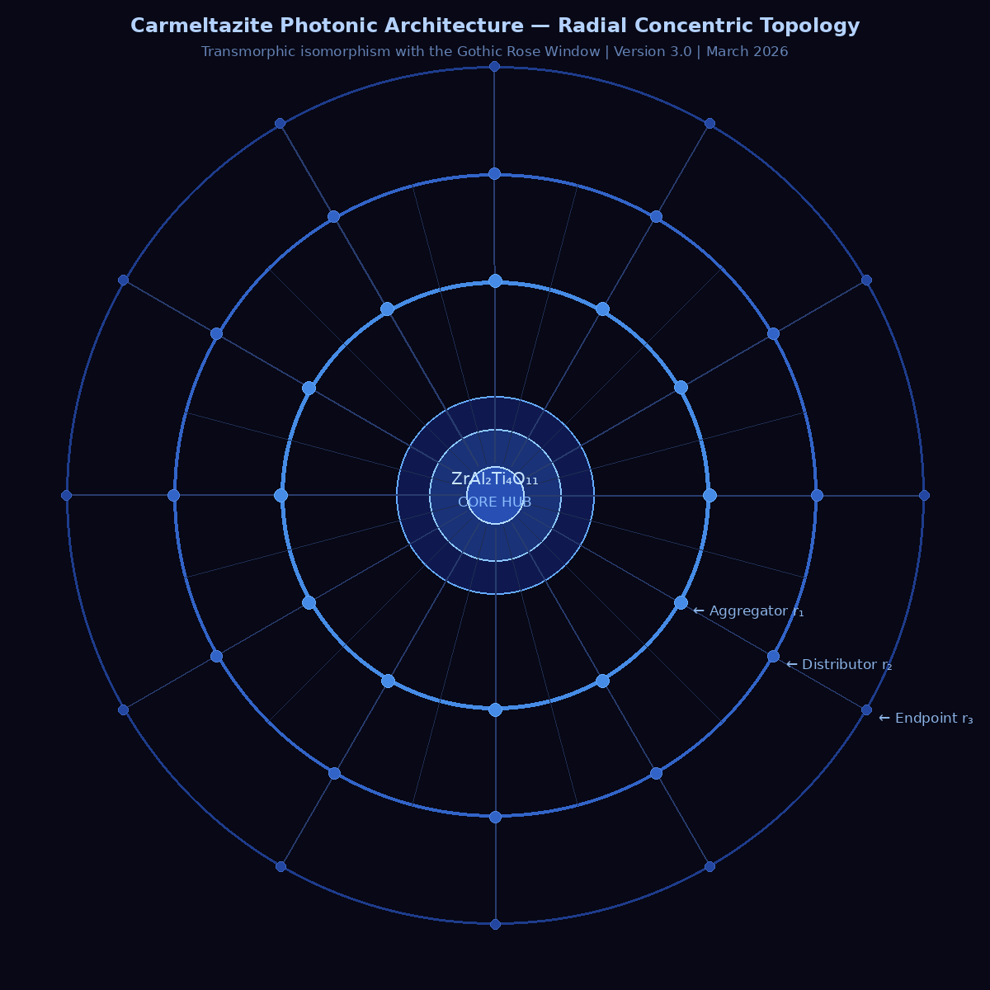
Figure 2. Radial concentric topology: transverse cross-section of the proposed integrated photonic architecture. Central node (v_hub): carmeltazite optical hub. First ring (r₁, blue): Aggregator layer — TiO₂ waveguides, Al₂O₃:Er amplifiers, ZrO₂:Al modulators, HfZrO₂ memory. Second ring (r₂, medium blue): Distributor layer — WDM Mux/Demux, TFLN modulators, MEMS OXC. Outer ring (r₃, dashed): Endpoint layer — CFP2-DCO 400ZR, Flexi-grid ROADM, OFEC codec. Primary spokes (24 total): hub-to-endpoint radial paths. Twelve nodes per ring represent functional modules, not physical fibres.

V. Component Architecture — Layer-by-Layer Specification
The following table provides the full component specification for each layer. Epistemic status is assigned per component, not per layer. All non-carmeltazite components are at axiom level A2 (established, commercially demonstrated or published in peer-reviewed literature).

Layer | Component | Function | Key Parameter | Rose W. | Status
Core | ZrAl₂Ti₄O₁₁ substrate | Central optical hub, master substrate | n ≈ 2.0–2.3 (H2); T_stability > 1200°C (A1) | Oculus | C1
Core | N×N optical switch matrix | Lambda routing, no O-E-O conversion | Port count ≥ 32×32; IL < 3 dB | Hub | A2
Aggregator | TiO₂ photonics (anatase) | Broadband waveguide, low TPA | n = 2.33 (A2); TPA ≈0.1 cm/GW | Primary lancet | A2
Aggregator | ZrO₂:Al₂O₃ ALD (high-k) | Gate capacitor, electrostatic phase shift | εr ≈ 20 (A2); Vπ < 3 V | Reinforcing rib | A2
Aggregator | Al₂O₃:Er³⁺ (1–3×10²⁰ ions/cm³) | Distributed C-band amplification | Gain 2–4 dB/cm @ 1530–1565 nm (A2) | Coloured glass | A2
Aggregator | HfZrO₂ ferroelectric | Photonic memory, non-volatile phase shift | P_r > 10 μC/cm²; Vπ < 2 V (A2) | Lead came | A2
Distributor | DWDM Mux/Demux 96λ | Dense frequency multiplexing, ITU 100 GHz | IL < 2 dB; crosstalk < −30 dB (A2) | Spoke network | A2
Distributor | Thin-film LiNbO₃ modulator | Electro-optic encoding, 100 Gbaud | BW > 100 GHz; Vπ < 2 V; IL < 3 dB (A2) | Active spoke | A2
Distributor | Reconfigurable MEMS OXC | Lambda switching, 1+1 protection | Switching time < 10 ms; IL < 1.5 dB (A2) | Joint | A2
Endpoint | CFP2-DCO 400ZR | Long-haul client, 400 Gbit/s coherent | DP-16QAM; OSNR < 16 dB; OIF 400ZR-01.0 (A2) | Peripheral foil | A2
Endpoint | Flexi-grid ROADM | Lambda plane reconfiguration, 6.25 GHz | WSS insertion loss < 7 dB (A2) | Finial | A2
Endpoint | OFEC / SD-FEC codec | Error correction, system margin management | Net coding gain > 11 dB; latency < 100 ns (A2) | Lead sealing | A2

VI. System Performance Projections
The following performance figures are derived from established component specifications (A2) and are architecture-level projections. They are not dependent on the carmeltazite hypothesis and would hold if an alternative high-index substrate is substituted for the Core layer.

6.1 Aggregate Capacity
Parameter | Value | Basis
WDM channels | 96 λ (100 GHz grid) / 192 λ (50 GHz flex-grid) | ITU-T G.694.1 (A2)
Per-channel data rate | 400 Gbit/s (DP-16QAM, 100 Gbaud) | OIF 400ZR-01.0 (A2)
Aggregate throughput (100 GHz grid) | 96 × 400 Gbit/s = 38.4 Tbit/s | Calculated from A2 specs
Aggregate throughput (flex-grid) | 192 × 400 Gbit/s = 76.8 Tbit/s | Calculated from A2 specs
FEC net coding gain | > 11 dB (OFEC) | Published OFEC specifications (A2)
Pre-FEC BER target | < 2×10⁻² (corrected to < 10⁻¹µ) | Standard OFEC operating point (A2)
Timing jitter tolerance | < 100 fs (400 Gbaud, 16-QAM) | Constellation rotation < 7° penalty < 1 dB

6.2 Optical Link Budget (Conservative Estimate)
Loss Element | Budget (dB) | Mitigation
Hub coupling (carmeltazite → TiO₂ waveguide) | 1.5–3.0 (H2) | Adiabatic taper; index-matching layer
TiO₂ propagation (aggregator, 10 mm) | 0.5–1.0 (A2) | Anatase TiO₂, proven < 1 dB/cm
Al₂O₃:Er³⁺ amplifier gain | −2.0 to −4.0 (A2) | Compensates aggregator losses
WDM Mux/Demux (distributor) | 2.0–3.0 (A2) | Athermal AWG or thin-film filter
TFLN modulator insertion loss | 2.0–3.0 (A2) | Spot-size converters at I/O
MEMS OXC insertion loss | 1.5 (A2) | Free-space MEMS, < 1.5 dB
Endpoint coupling (ROADM → CFP2-DCO) | 1.0–2.0 (A2) | Standard SMF connectorisation
Total system budget (A2 components only) | 6.5–10.5 dB net (after Er³⁺ gain) | Within coherent receiver sensitivity margin

Note: The hub coupling loss is the only budget item that depends on the carmeltazite hypothesis (H2). If n_carmeltazite falls below 1.9, the index contrast with TiO₂ cladding is insufficient and hub coupling must be redesigned with an intermediate layer.

VII. Technological Barriers and Open Questions

7.1 Barriers Directly Addressable by Phase 1 Measurements
# | Barrier | Experiment That Resolves It | Success Criterion | If Failed
B1 | n_carmeltazite unknown — modal confinement unproven | Ellipsometry (Measurement 1) | n > 1.9 @ 1550 nm | Architecture requires redesign; hub material replaced
B2 | Absorption losses at telecom wavelengths unknown | Spectrophotometry (Measurement 2) | Loss < 1 dB/cm | Passive guide only; active hub excluded
B3 | Dielectric constant unknown — active modulation unproven | C-V measurement (Measurement 4) | εr > 15 | External electro-optic modulator required
B4 | Surface quality unknown — lithographic compatibility unproven | AFM (Measurement 5) | Sq < 0.3 nm | Material unsuitable for DUV patterning
B5 | Birefringence unknown — polarisation management undefined | Polarimetry (from Measurement 1) | Δn characterised | Polarisation-maintaining design required

7.2 Barriers Deferred to Subsequent Programme
The following barriers are real but are explicitly deferred beyond the scope of this blueprint. They are listed here for completeness and to prevent them from being conflated with Phase 1 deliverables.

- B6 — ALD synthesis of orthorhombic ZrAl₂Ti₄O₁₁: H3. Plausible by analogy with RTA of ZrO₂:Al₂O₃ systems, but not demonstrated. Estimated 2–3 years of experimental optimisation (T, atmosphere, precursor chemistry, RTA parameters).
- B7 — CMOS process integration: Heterogeneous bonding of carmeltazite on SOI or SiN platform via BCB or SiO₂/SiO₂ direct bonding. Wafer bow and CTE mismatch are anticipated challenges.
- B8 — Long-term reliability: Stability under intense optical flux (> 100 mW/waveguide) and thermal cycling (−40°C to +85°C). No data exists for natural carmeltazite under these conditions.

7.3 What Remains Genuinely Unknown
Complete intellectual honesty requires naming the limits of the current model:
- Whether the orthorhombic lattice of carmeltazite produces emergent optical properties distinct from the constituent oxide average is unknown and cannot be determined without measurement. The hypothesis is physically motivated (inter-site charge transfer, crystal field splitting at Zr-Ti interfaces) but not theoretically calculated.
- The nonlinear refractive index n₂ of carmeltazite is unknown. If n₂ is anomalously large (as observed in some perovskite-related structures), cross-phase modulation between WDM channels at the hub will limit usable power per channel and impose guard-band requirements.
- The photoluminescence behaviour of carmeltazite under 980 nm or 1480 nm pump irradiation is unknown. If Ti³⁺ centres are present (which oxygen vacancy formation at high temperature can produce), they may generate parasitic fluorescence within the C-band amplification window.

VIII. Conclusion
This blueprint establishes the rigorous foundations for a two-phase research programme. The epistemic architecture is explicit throughout: nine properties of the established mineralogical record (A1), eight optical and dielectric properties of carmeltazite await measurement (H2), and the terabit substrate conjecture (C1) is formally contingent on Phase 1 results.

The four-layer radial concentric architecture is functionally coherent and technically specified with published component parameters. Its topological, variational, and transmorphic isomorphism with the Gothic rose window is formalised in graph-theoretic terms, with explicit identification of preserved invariants and analogy limits. This transforms the structural parallel from rhetorical ornament into a defensible architectural proposition.

The next action is unambiguous and material-driven: obtain natural carmeltazite specimens and execute the five priority measurements defined in Section III. A positive result in Measurements 1 and 2 — n > 1.9 and absorption < 1 dB/cm at 1550 nm — would constitute the first demonstration of carmeltazite as a photonically viable material and would justify the full characterisation campaign and subsequent ALD synthesis programme.

A negative result would be equally valuable: it would redirect research toward a ZrO₂:TiO₂ ALD composite with optimised stoichiometry, informed by the structural blueprint developed here. The architecture stands independent of the substrate identity. The rose window topology is the contribution; carmeltazite is the candidate material under investigation.

――――――――――――――――――――
It is remarkable that a mineral first detected in meteoritic material, then discovered in the most extreme pyrometamorphic xenoliths of Earth’s lithosphere, presents the elemental co-crystallisation that photonic engineering has been assembling separately for two decades. This document does not assert that nature solved the problem. It asserts that nature provides a structural model worth measuring — with rigour commensurate with the ambition.

References
Axiom-level references (A1/A2/A3) — all claims at axiom level are directly traceable to one of the following:

[A1] Murashko M.N., Vapnik Ye., Sharygin V.V., Zanvilevich A.N., Krivitskaya N.N. (2017). Carmeltazite, ZrAl₂Ti₄O₁₁, a new mineral from Hatrurim Complex, Negev Desert, Israel. Mineralogy and Petrology, 111(6), 923–932. DOI:10.1007/s00710-017-0518-2
[A2a] Evans C.C., Liu C., Ryou J. (2016). TiO₂ nanophotonic waveguides. Optics Express, 24(8), 8366–8376.
[A2b] Boes A., Corcoran B., Chang L., Bowers J., Mitchell A. (2018). Status and potential of lithium niobate on insulator. Laser & Photonics Reviews, 12(4), 1700256.
[A2c] Mikolajick T. et al. (2021). Next generation ferroelectric materials for semiconductor process integration. J. Appl. Phys., 129(10), 100901.
[A2d] Wilmart Q. et al. (2019). A versatile silicon–silicon nitride photonics platform. Applied Sciences, 9(2), 255.
[A2e] Rios C. et al. (2019). In-memory computing on a photonic platform. Science Advances, 5(2), eaau5759.
[A2f] ITU-T G.694.1 (2020). Spectral grids for WDM applications: DWDM frequency grid. International Telecommunication Union.
[A2g] OIF Implementation Agreement OIF-400ZR-01.0 (2020). 400ZR Coherent Optical Module Standard. Optical Internetworking Forum.
[A3] Diestel R. (2017). Graph Theory, 5th ed. Springer. — For topological properties of planar radial graphs, Chapter 4.
[H2] Palik E.D. (Ed.) (1985). Handbook of Optical Constants of Solids. Academic Press. — Source data for linear mixing rule extrapolation. Extrapolation to ZrAl₂Ti₄O₁₁ is H2, not A2.

